

***Mobile Services Platform***

***Administration User Manual***

**Confidentiality Notice**

*Use or disclosure of information contained in this document is subject to the restriction contained below.*

This document contains information proprietary & confidential to XIUS. It shall not be duplicated, used or disclosed in whole or in part for any purpose. Any disclosure, reproduction, duplication, transmittal or distribution of this document in whole or in part, using physical, electronic or any other media, requires written consent from an authorized XIUS signatory.

[www.xius.com](http://www.xius.com)

**Table of Contents**

1 Introduction 4

2 Acronym and Definition 5

3 MSP Features 6

3.1 Modules 7

3.1.1.1 Super Administrator 7

3.1.2 Network Administrator 7

3.2 Target Audience / User Types for the Product 8

3.3 Super Administrator Login 9

3.3.1 Network Details 10

3.3.2 System Configuration 24

3.3.3 HLR Configurations 25

3.3.4 Manage Country / State Codes 27

3.4 Network Operator Login 39

3.5 Application Logout 41

**Revision History**

|  |  |  |  |  |
| --- | --- | --- | --- | --- |
| Document ID | | **AG-HLR ADMINISTRATION** | | |
| Document Title | | HLR Administration User Guide | | |
| Version No | Date | Description | Prepared  by | Approved by |
| 1.0 | 19th,Apr 2017 | Initial Publication | Tech.Publications |  |

# Introduction

**XIUS-Mobile Services Platform (MSP)** is an exhaustive **Convergent Billing and Service Delivery** solution built on a turnkey technology and services platform that offers an innovative business and operational model for **bringing together Mobile Virtual Network Operators (MVNO) and Mobile Network Operator (MNO)**.

Despite MVNO having full control over the SIM card subscription, branding, marketing, billing, customer care operations and any other related services, stipulation of partial access to the Operational Support Systems (OSS) and Business Support Systems (BSS) by the incumbent mobile network operator tend to have certain processes and procedures separated and disconnected from those of the MVNO. This scenario restricts the provisioning of an intelligent and single technology (an integrated and independent platform). To surmount this pain point, XIUS has come up with **MSP** a technology expertise to offer a single and dynamic ecosystem, providing the increased ROI and reduced TCO for all participants.

MSP rightly addresses these complex OSS/BSS infrastructure needs in order to provide the critical customer-facing MNVO services (customer care, order management, billing, assurance) in a multi-partner / multi-network environments and independent wireless network circumstances. MSP supports the complex business process management framework that is required to support the variety of enterprise applications, 3rd party providers and business processes of multiple MVNO.

Besides providing the entire gamut of mobile billing services and promotional offerings, MSP also caters to the provisioning of VAS services to the end customers, giving them the flexibility of being both ‘mobile’ and ‘VAS + Mobile’ subscribers. However, MSP outfits to the exact MVNO needs enabling to provide a tailor-made/configurable solution (with the MVNO desired components), and thus ensures the MVNO to pay for what it requires and not for the entire platform.

MSP is a bottom-line solution, which enhances the MVNO’ productivity to concentrate on its core business (brand building, customer loyalty, increase ARPU, rollout innovative customer specific services etc) rather than being entangled in network intricacies.

# Acronym and Definition

|  |  |  |
| --- | --- | --- |
| **S.No** | **Acronym** | **Definition** |
|  | BSS | Business Support Systems |
|  | HLR | Home Location Register |
|  | IP Services | Internet Protocol (Service) |
|  | LRN | Location Routing Number |
|  | MMSC | Multimedia Messaging Service Center |
|  | MNO | Mobile Network Operation |
|  | MSP | Mobile Services Platform |
|  | MVNO | Mobile Virtual Network Operator |
|  | OSS | Operational Support Systems |
|  | PLMN | Public Land Mobile Network – services |
|  | RSCP | Reverse Service Control Point |
|  | SMSC | Short Message Service Center |
|  | VOIP | Voice Over Internet Protocol |
|  | MSISDN | Mobile Subscriber Integrated Services Digital Network Number |
|  | N/w Id | Network Identification (MVNOs Identifier) |
|  | ACM | Allow Call Mode |
|  | MNP | Mobile Number Portability |
|  | HSS | Home Subscriber Server |

# MSP Features

Mobile Services Platform is an exhaustive and integrated web application scalable to the wide spectrum of Telecom Industry needs. This application is a one stop solution that caters to the administration of various independent network operators under a central control system. Nevertheless, the independent network operators shall be provided the freedom of exercising their operations within the sphere of their corresponding network systems.

Super Administrator is the chief of the MSP application who controls the multiple network systems; whereas a Network Administrator is the chief of his / her independent network. However, the operations of a network operator shall be based on the corresponding business scope and the choice of service offerings.

## Modules

#### Super Administrator

Super Administrator creates various user accounts for multiple network operators and configures their admission or right to use of MSP system based on their individual business scope and their area operations. Super user handles the entire network management through the following modules.

* **Network Management**
* Network Details
* System Configuration
* Manage Network Codes
* HLR Configuration
* Manage Country / State Codes

### Network Administrator

An authorized network operator can have access to the following modules, however, subject to the extent of admission rights (for using various modules) provided by the Super User in accordance with the Network Operator’s business scope. In other words, accessibility of the MSP system by the network operator shall be limited to the area of his / her service offerings in the Telecom space.

* Public Land Mobile Network (PLMN) Services
* Billing Management
* User Management System
* Inter Connect Billing Management

## Target Audience / User Types for the Product

This document is intended for the use of Administrative, Operative and Customer care departments of the XIUS mobile services clients.

## Super Administrator Login

Super Administrator login page helps the Super User logging into MSP to create and manage the user accounts of various Network Operators. Besides the creation and management of the user accounts, Super User owns the complete control of the MSPapplication.

Authorized Network Operators can login to the MSP application with the help of their respective Login IDs and passwords, which enable them to manage their functional operations within their independent networks.

The screen below shows Login page for the Super User.

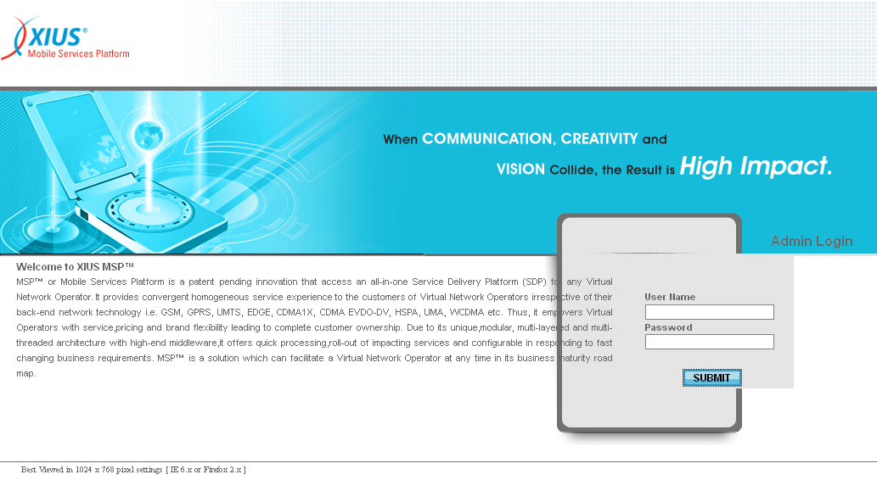

| **STEP** | **ACTION** |
| --- | --- |
|  | Super User to enter his / her valid user name and password in their respective <User Name> and <Password> fields. |
|  | On clicking the Super Log In button, ‘Administrator Home Page’ will be displayed, enabling the Super User to access the related modules. |

The screen below shows the Super User (Administrator) Home Page.

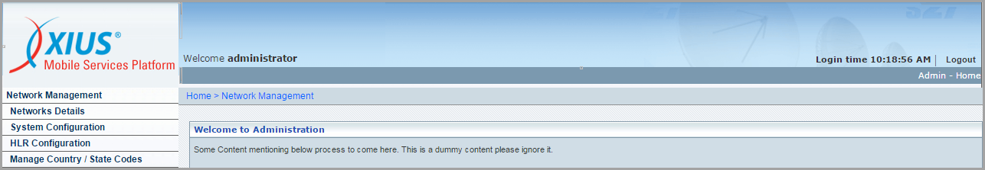

### Network Details

Network Management 🡪 Network Details

**‘Network Details’** allows the Super User (**SU**) creating and managing (activate, deactivate and password change etc.) the user accounts for various Network Operators.

This screen further allows the user to perform following actions:

* View Network Details
* Modify Network Details
* Configure (certain) Network Details

This sub-module also helps to fetch a single record (details related to any given Network) with the help of the **‘Search’** option based on the provided search criterion. The search criteria include: Network Name and Network Code.

Initially, the list of existing Networks (Network User Accounts) will be displayed in a grid.

The screen below shows the creation & management of User Accounts of the different Network Operators.

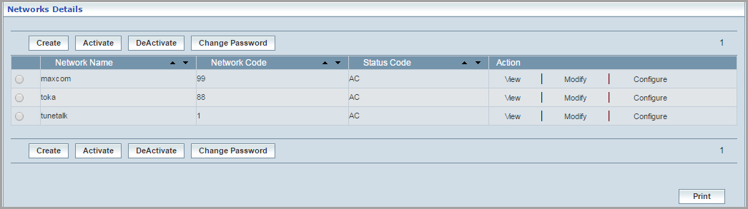

| **STEP** | | **ACTION** |
| --- | --- | --- |
|  | | By default, list of records for the existing Network Operators (the corresponding User Accounts) will be displayed in a grid. The columns include ‘Network Name’, ‘Network Code’, ‘Status Code’ and ‘Action’ |
|  |  | User can customize the view for the number of records to be displayed each time (per page) in a grid. |
| Select the number of records (For Ex: 10) from the drop-down list of the <View Per Page> field. |
| With the effect of choosing the desired number (10) for the display of records per page, the same (10 records) will be displayed in the grid. |
| However, based on the total number of records, page numbers will be dynamically displayed at the left bottom of the screen. |
| User can navigate for subsequent records (10 each time) by clicking the desired ‘page number’ |
|  | | User can sort the records in ascending and descending orders with the help of up-arrowNW Details and down-arrows NW Details respectively. |
|  | | ‘Status Code’ indicates status (‘Active - **AC**’ or ‘Inactive - **DA**’) of the User Account (Network Operator). |
|  | | On clicking the  button, ‘Create Network’ screen will be displayed, which enables the user to create a new Network. |
|  | | User can ***activate or*** ***deactivate*** the user account (Network Operator’s Account) by the Super Administrator accordingly and as required. |
|  | | On clicking the  button, ‘Change Password’ screen will be displayed, which enables the **SU** to change password of the user account (Network Operator’s Account). |
|  | | On clicking the  link of a chosen network, the corresponding details will be displayed in a separate screen. |
|  | | On clicking the  link of a chosen network, the corresponding details will be displayed in a separate screen, which enables the **SU** to update / modify network details. |
|  | | On clicking the  link of a chosen network, ‘Configure Details’ screen will be displayed, which enables the user to configure / update existing configuration related to the new / existing Network accordingly and as the case may be. |
|  | | User can print the list of records with the help of NW Details button at the left bottom of the screen. |

**Create:**

The screen below shows creating a new User (Network User) Account.

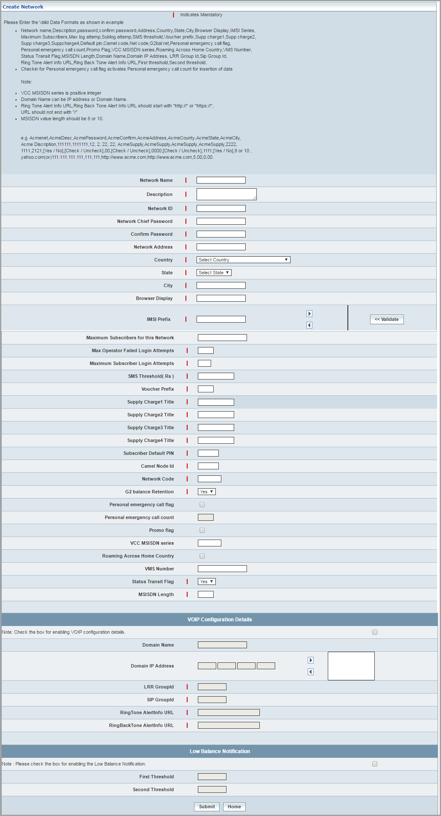

| **STEP** | **ACTION** |
| --- | --- |
|  | **Create User Account:** On clicking the  button, **‘Create Network’** screen will be displayed, enabling the user to create a ***new user account*** by entering the details of a Network Operator in the relevant fields. |
|  | User must go through and follow the guidelines (provided in an example) before specifying the details of a Network Operator. Dynasty |
|  | User must essentially enter the details of the Network Operator (User Account) where it is mandatory. |
|  | IMSI Prefix:  Minimum length of IMSI Prefix must be 5 and maximum 15 digits and it must be unique, thus needs to be validated for duplication.  User can enter multiple IMSI Prefix values to a network (each at a time) an by clicking the right arrow  button, the given IMSI Prefix will be moved to the adjacent list box.  **To remove an IMSI Prefix value from the group:** Select the IMSI Prefix that needs to be removed from the list box and by clicking the left arrow  button, the same will be removed.  However the proposed group of IMSI Prefix values has to be unique and thus needs to be validated for duplication.  On clicking the  button, it displays a message window indicating if the IMSI Prefix(s) is used or not in used across any other network. |
|  | Voucher Prefix:  Length of Voucher Prefix must be 2 digits and unique, thus needs to be validated for duplication.  On clicking the  button, it displays a message window indicating if the given Voucher Prefix is already used or not used across in another network. |
|  | Network Code:  Minimum length of Network Code must be 1 and maximum of 5 digits and it must be unique, thus needs to be validated for duplication  On clicking the  button, it displays a message window indicating if the given Network Code is already used or not used across in other network |
|  | **VOIP Configuration Details:**  Only after selecting the  check box, the ‘VOIP Configuration Details’ fields will be activated, enabling the user to enter data accordingly  Domain IP Address:  User can enter multiple Domain IP Addresses to a network (each at a time) an by clicking the right arrow  button, the given Domain IP Address will be moved to the adjacent list box  However, each Domain IP Address of the group must be unique  **To remove a Domain IP Address** **from the group:** Select the Domain IP Address that needs to be removed from the list box and by clicking the left arrow  button, the same will be removed |
|  | **Low Balance Notification:**  Only after selecting the  check box, the ‘Low Balance Notification’ fields will be activated, enabling the user to enter data accordingly  First threshold value must be less than or equal to 5 and must always be greater than Second threshold value |
|  | On clicking the  button, the new user account will be created and saved to the records grid. By default, the New Network User Account shall be active  It automatically redirects the user to the records grid, where the New User record is appended to the existing list of records. A message window will be displayed to that effect |
|  | On clicking the  button, it clears the screen (before submitting the details), enabling the user to enter the details afresh |
|  | On clicking the  button, it only redirects the user back to the (Network) records grid |

**Deactivate:**

To deactivate a network (that is active), user must select the radio option  of a chosen network. By clicking the  button, an alert message window will be displayed enabling the user to confirm deactivation of the network.

The screen below shows deactivation of a (Network) User Account.

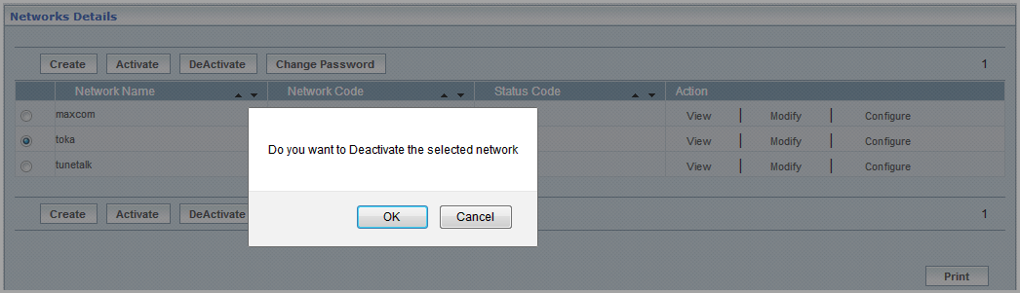

| **STEP** | **ACTION** |
| --- | --- |
|  | On clicking the  button of the alert message window, corresponding network details will be displayed in a separate screen, enabling the user to deactivate |
|  | On clicking the  button of the alert message window, it retains the network records grid without any action |

The screen below shows confirming the deactivation of the chosen (Network) User Account.

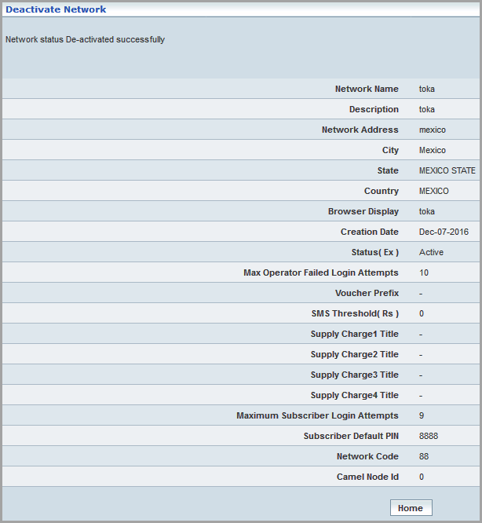

| **STEP** | **ACTION** |
| --- | --- |
|  | On clicking the  button of the ‘Deactivation Details’ screen, ‘deactivation’ shall be effective and it redirects the user back to the records grid. Corresponding ‘Status Code’ of the user (Network Operator) will be dynamically changed to ***inactive*** **‘DA’** |

**Activate:**

To activate a network (that is inactive), user must select the radio option  of a chosen network. By clicking the  button, an alert message window will be displayed enabling the user to confirm activation of the network

The screen below shows activation of a (Network) User Account.

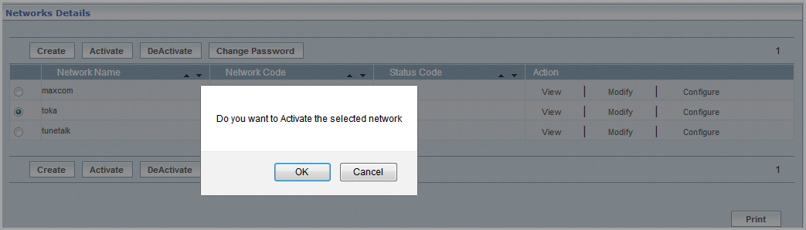

| **STEP** | **ACTION** |
| --- | --- |
|  | On clicking the  button of the alert message window, corresponding network details will be displayed in a separate screen, enabling the user to activate |
|  | On clicking the  button of the alert message window, it retains the network records grid without any action |

The screen below shows confirming the activation of the chosen (Network) User Account.

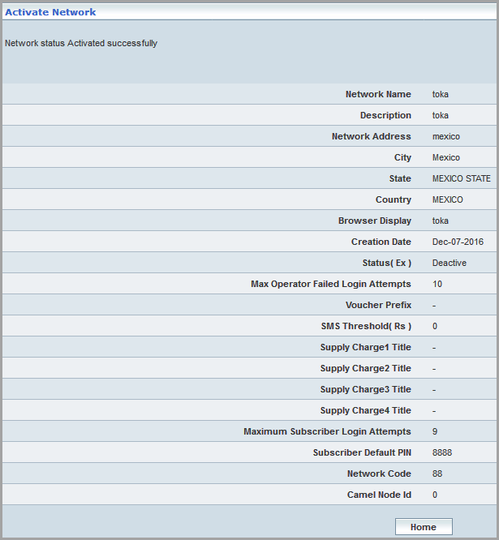

| **STEP** | **ACTION** |
| --- | --- |
|  | On clicking the  button of the ‘Activation Details’ screen, ‘activation’ shall be effective and it redirects the user back to the records grid. Corresponding ‘Status Code’ of the user (Network Operator) will be dynamically changed to ***active*** **‘AC’** |

**Change Password:**

The screen below shows changing the password for the selected User Account.

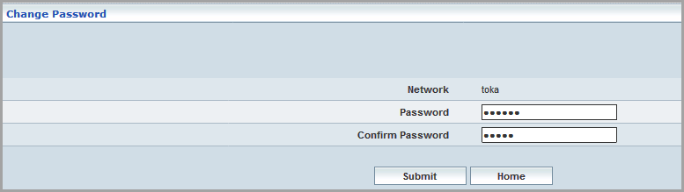

| **STEP** | **ACTION** |
| --- | --- |
|  | **Change Password:** In the **Network Details** screen, select a network name to change the password of a user account (Network Operator). |
|  | On clicking the  button, it displays the corresponding user account (Network Operator account) ‘Password Change’ screen (for Ex: ) |
| User to enter new password and confirm the password in <Password> and <Confirm Password> fields respectively. |
| On clicking the  button, the new password will be effective and the same can be used by the concerned Network Operator. Password change message will be displayed to that effect with a  button at the bottom of the message window.  NW Details  On clicking the  button of the ‘Message Window’, it redirects the user back to the records grid |
| On clicking the  button of the ‘Change Password’ screen prior to any changes made, it redirects the user back to the records grid. |

**View:**

The screen below shows the ‘View’ of the User Account details.

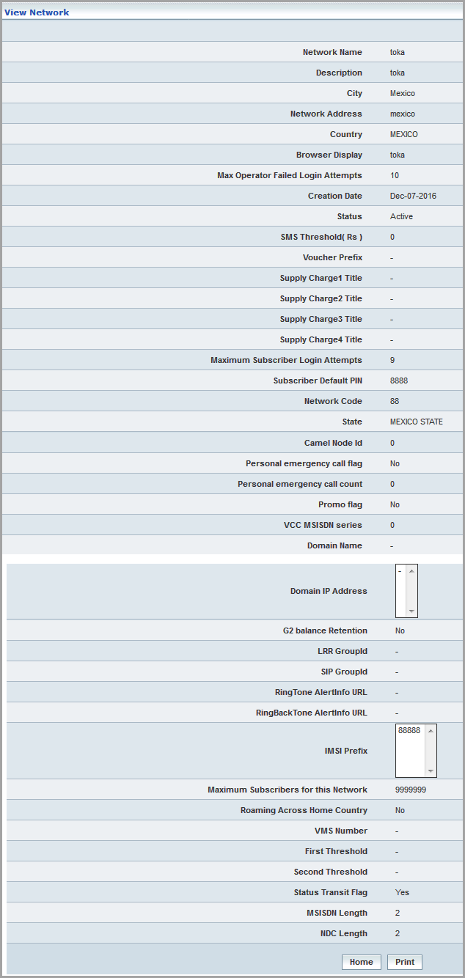

| **STEP** | **ACTION** |
| --- | --- |
|  | On clicking the  link of a chosen Network Operator (record), corresponding details of the Operator will be displayed in a screen |
|  | User can print the details with the help of NW Details button at the bottom of the screen |
| On clicking the  button, it redirects the user back to the records grid |

**Modify:**

The screen below shows ‘Modifying/Updating’ the User Account details

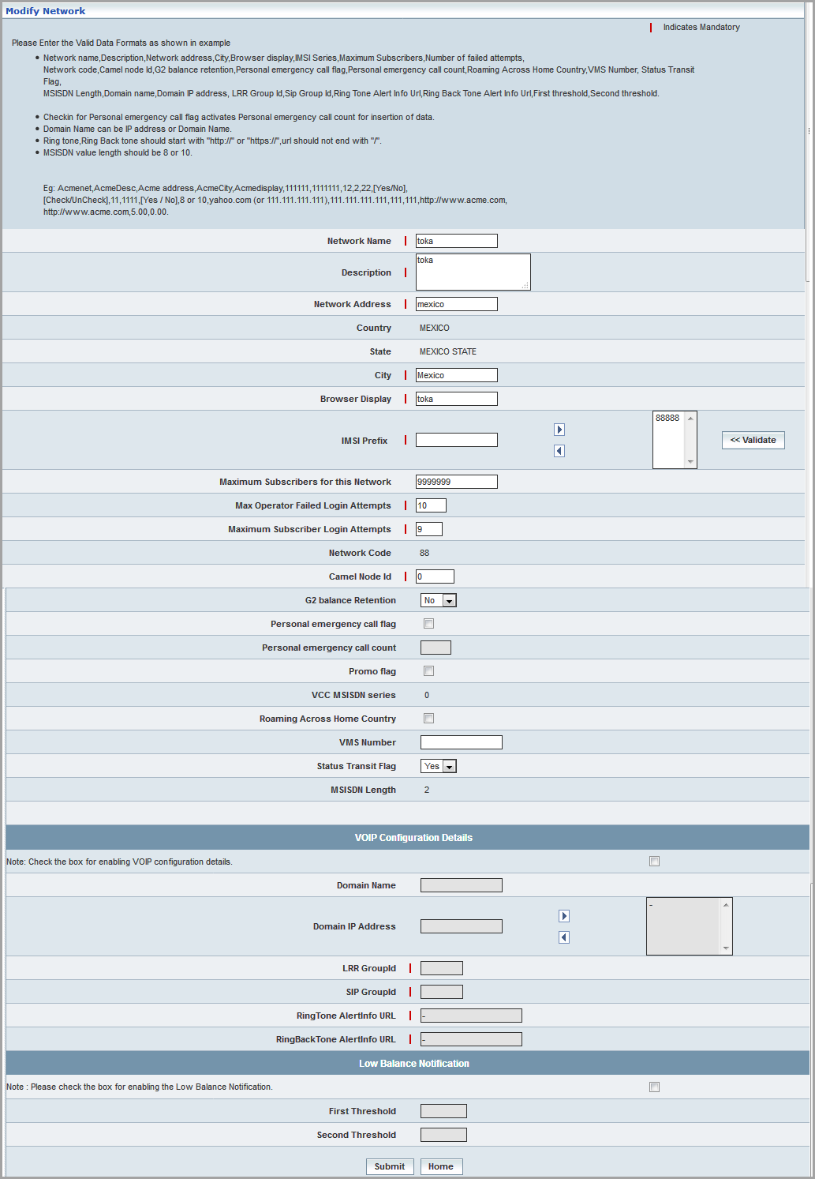

| **STEP** | **ACTION** |
| --- | --- |
|  | On clicking the  link of a chosen Network Operator (record), corresponding details of the Operator will be displayed in a screen |
|  | User can modify or update the details related to Network Operator as appropriate |
| On clicking the  button, the (Network User Account) record gets updated and redirects the user back to the records grid. A message window will be displayed to that effect    On clicking the  button of the message window, it directs the user back to the records grid |
|  | On clicking the  button, it only redirects the user back to the records grid |

**Configuration:**

‘Configuration’ link helps the user configuring the following elements to the chosen network:

* **HLR Multi Sub Profile Support Flag**
  + By default, the HLR Multi Sub Profile Support Flag is set to **<NO>** then HLR Multi Sub Profile Support feature would be disabled
  + On the other hand, if HLR Multi Sub Profile Support Flag is set to **<YES >** HLR Multi Sub Profile Support feature would be enabled
* **3G HLR Integration**
  + By default, 3G HLR Integration is set to **<NO>**
  + If the 3G HLR Integration is set to **<YES>**, the configuration is applicable to the selected network. Hence, by virtue of this configuration, the parameters relevant to 3G HLR are enabled in PDP (Packet Data Protocol) Profile Management. For more information refer, *HLR User Manual*.
* **Authentication** **Upload Process** 
  + By default, Authentication Upload Process is set to/selected as **<Key Value Pairs Process>**, and this enables the key (KI) value pair process at network user login. The ‘KI Value’ is mandatory during the authentication of a subscriber. For more information refer, *HLR User Manual*
  + On the other hand, if Authentication Upload Process is selected as **Normal Process** (the K value paring process would be disabled and) enables the Normal process
* **Authentication Index Details View**
  + By default, Authentication Index Details view is set to **<YES>** then Authentication Index Details View feature would be enabled
  + On the other hand, if Authentication Index Details view is set to **<NO>** then Authentication Index Details View feature would be disabled
* **Enable HSS**
  + By default, Enable HSS is set to **<NO>** then the services relevant to HSS (APN Profiles) would be disabled and the services relevant to the 3G HLR (Camel Services) would be enabled
  + On the other hand, if Enable HSS is set to **<YES>** then Enable HSS services relevant to HSS (APN Profiles) would be enabled and the services relevant to HLR would be disabled
  + Select **HLR & HSS** to enable the services relevant to both 3G HLR and HSS

The screen below shows configuring the details to a network.

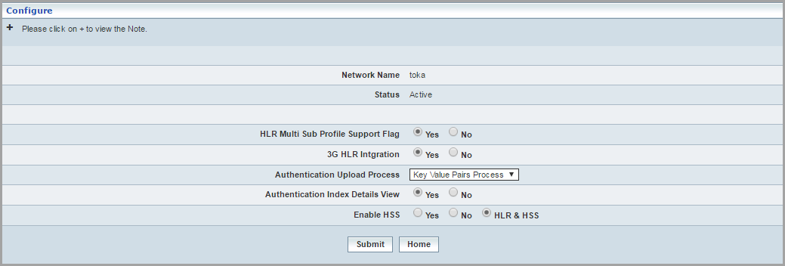

| **STEP** | **ACTION** |
| --- | --- |
|  | On clicking the  link of a chosen Network Operator (record), corresponding details will be displayed in a screen enabling the user to configure details accordingly |
|  | Select a radio option to specify the <HLR Multi Sub Profile Support Flag>, Yes/No |
|  | Select a radio option to specify the <3G HLR Integration> by selecting Yes/No |
|  | Select type of authentication upload process from the <Authentication Upload Process> drop down list |
|  | Select a radio option to specify the <Authentication Index Details View > by selecting Yes/No |
|  | Select a radio option to specify the <Enable HSS > by selecting Yes/No/HLR & HSS |
|  | On clicking the  button, the (Network User Account) record gets updated along with the configured parameters and it redirects the user back to the records grid. A message window is displayed to that effect.  Wor3C6  On clicking the  button of the message window, it directs the user back to the records grid. |
|  | On clicking the  button, it only redirects the user back to the records grid. |

### System Configuration

**System Configuration** module allows the Super User (**SU**) to determine or fix the **MSP**Application ***stand by time*** when the user leaves it idle. This module also helps ‘**SU**’ to decide on default setting activated for log generation of the user activities (series of actions performed by the user while using the **MSP**Application). This enables tracking of user activities, i.e., dynamic generation of a log (list of records) at the backend for the series of user activities while using the application.

The term ‘Enable Console Output’ is to depict the ‘**report’** that would be dynamically generated for the user activities during the usage of **MSP**Application.

The screen below shows the Super User fixing ‘Session Time Out’ and also enabling & disabling the ‘Enable Console Output’.

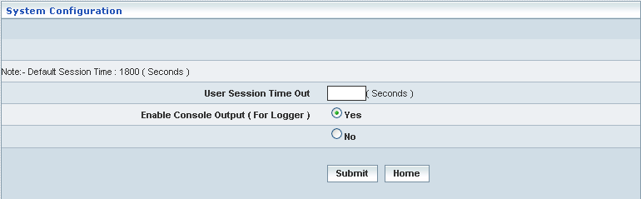

| **STEP** | **ACTION** |
| --- | --- |
|  | User to enter the time ***in seconds*** to fix the ‘session time out duration’ in the <User Session Time Out> field |
|  | Select the radio option  ‘**Yes’** to enable the dynamic generation of ‘User activities log report’ – **Enable Console Output**. By default, the system always indicates the selection of radio option  ‘**Yes’** and hence, it is recommended for the user |
| User can choose the radio option  ‘**No’** to disable the dynamic generation of ‘User activities log report’ – **Enable Console Output**. However, this is not recommended for the user |
|  | On clicking the  button, the ‘Session Time Out’ duration stands good and effective for the ‘Application Stand By Time’ till the next change. ‘Session Time Out’ update message will be displayed to that effect with a ‘**Home**’ button at the bottom of the message window  WorC  On clicking the  button of the ‘Message Window’, it redirects the user back to the Application Home Page |
| On clicking the  button of the ‘Session Time Out’ screen prior to any updates, it redirects the user back to Home Page |

### HLR Configurations

Network Management 🡪 HLR Configurations

The ‘HLR Configuration’ feature allows the user to map the required activities to a network. Hence, by this configuration user can able to view the logs relevant to the mapped activities.

Initially, the list of existing Networks (Network User Accounts) will be displayed in a grid in the HLR configuration screen as shown below.

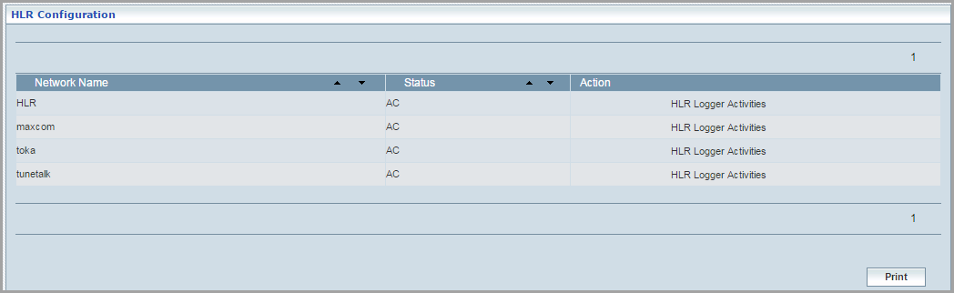

| **STEP** | **ACTION** |
| --- | --- |
|  | By default, list of records for the existing Network Operators (the corresponding User Accounts) will be displayed in a grid. The columns include ‘Network Name’, ‘Network Code’, ‘Status Code’ and ‘Action’ |
|  | User can sort the records in ascending and descending orders with the help of up-arrowNW Details and down-arrows NW Details respectively. |
|  | ‘Status Code’ indicates status (‘Active - **AC**’ or ‘Inactive - **DA**’) of the User Account (Network Operator). |
|  | User can print the list of records with the help of NW Details button at the left bottom of the screen. |
|  | On clicking the  button, ‘HLR Logger Activities’ screen will be displayed, which enables the user to map the required activities to a new Network. |

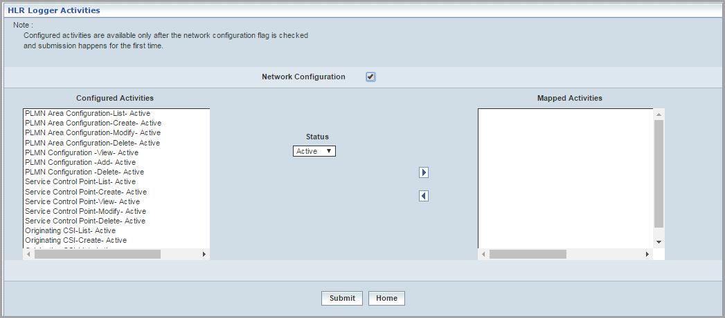

| **STEP** | **ACTION** |
| --- | --- |
|  | **Network Configurations**: Select the check box, so that the logs relevant to the configured activities are available for the user. |
|  | **Configured Activities**: Select the required the activities from the list, and click  to map the respective activities. Click  to deselect the mapped activities. |
|  | **Mapped Activities**:Displays the list of mapped activities for the logger activities. |
|  | **Status**:Select **Active** from the drop down list to view the logs relevant to the mapped activities. Select **Inactive**  **Note**: The records/logs related to the mapped activities shall be monitored at HLR DB. |
|  | On clicking the  button, the (Network User Account) record will be updated along with the configured parameters and it redirects the user back to the records grid. A message window is displayed to that effect. |
|  | On clicking the  button, it only redirects the user back to the records grid. |

### Manage Country / State Codes

**‘Manage Country / State Codes’** allows the Super User (**SU**) creating (add) country codes and subsequently create (ad) state codes for each of the countries.

This screen further allows the user to perform following actions:

* View Country Codes
* Modify Country Codes
* Delete Country Codes
* Manage State Codes
  + Create State Codes
  + View State Codes
  + Modify State Codes
  + Delete State Codes
  + Search State Codes

This sub-module also helps to fetch the records (Country) with the help of **‘Search’** option based on the provided search criterion. The search criteria include: Country Code, Country Description, and ISD Prefix.

Initially, the list of existing Country / State Codes will be displayed in a grid.

The screen below shows the creation & management of Country/State codes.

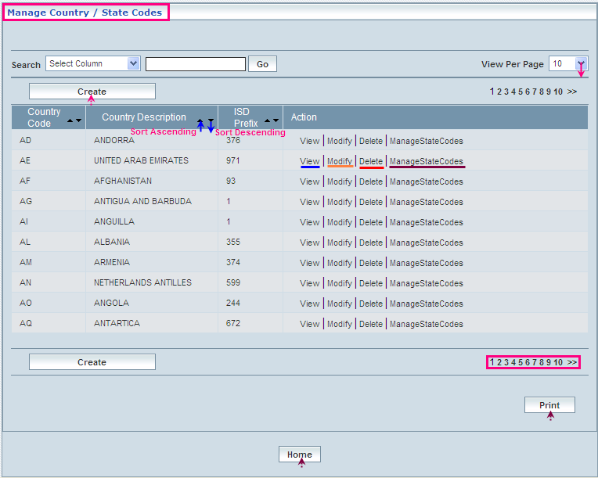

| **STEP** | | **ACTION** |
| --- | --- | --- |
|  | | By default, list of records for the existing Country/State Codes are displayed in a grid. The columns include ‘Country Code, ‘Country Description’, ‘ISD Prefix’, and ‘Action’. |
|  |  | User can customize the view for the number of records to be displayed each time (per page) in a grid. |
| Select the number of records (For Ex: 10) from the drop-down list of the <View Per Page> field. |
| With the effect of choosing the desired number (10) for the display of records per page, the same (10 records) will be displayed in the grid. |
| However, based on the total number of records, page numbers will be dynamically displayed at the right bottom of the screen. |
| User can navigate for subsequent records (10 each time) by clicking the desired ‘page number’ |
|  | | User can sort the records in ascending and descending orders with the help of up-arrowNW Details and down-arrows NW Details respectively |
|  | | On clicking the  button, ‘Create Country/State Code’ screen will be displayed, which enables the user to create a Country code |
|  | | On clicking the  link, the corresponding Country/State code details will be displayed in a separate screen |
|  | | On clicking the  link, the corresponding Country/State code details will be displayed in a separate screen, which enables the user to modify / update the details |
|  | | On clicking the  link of a chosen network, the corresponding details will be displayed in a separate screen, which enables the **SU** to delete the same |
|  | | On clicking the  link, the list of existing state codes if any will be displayed as records in a grid |
|  | | User can print the list of records with the help of NW Details button at the right bottom of the screen |
|  | | On clicking the  button of the ‘Manage Country/State Codes’ Grid, it redirects the user back to Home Page |

**Create:**

To create a Country code, click the  button. Create Country Code screen will be displayed enabling the user to create a new Country code.

The screen below shows creating a new ‘Country Code’

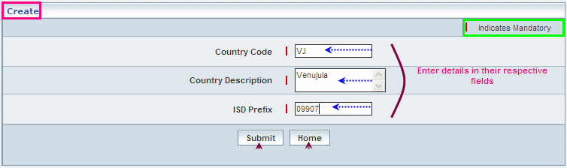

| **STEP** | **ACTION** |
| --- | --- |
|  | User must enter the ‘Country Code, Country Description, and ISD Prefix in their respective fields. |
|  | On clicking the  button, the new Country code will be part of the existing Country code(s) and a message window will be displayed to that effect.  **Wor5FB**  On clicking the  button of the message window, it redirects the user back to the (Manage Country/State Codes) records grid. |
|  | On clicking the  button of the **Create** screen, it redirects the user back to the (Manage Country Codes) records grid. |

**View:**

The screen below shows the ‘View’ of the selected Country code details.

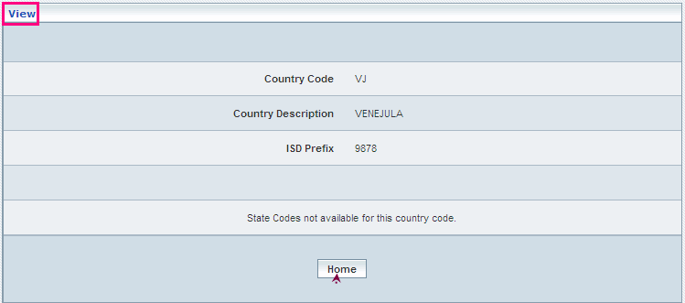

| **STEP** | **ACTION** |
| --- | --- |
|  | Click  in the Action Column of the screen against any Country code. |
|  | On clicking the  link of a chosen Country code, corresponding details will be displayed in a separate screen. |
|  | User can peruse the details accordingly. |
|  | On clicking the  button, it redirects the user back to the (Manage Country/State Codes) records grid. |

**Modify:**

The screen below shows the ‘Modify’ of the Country code details.

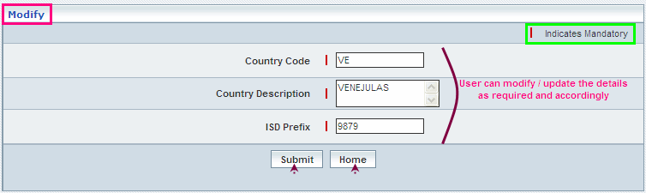

| **STEP** | **ACTION** |
| --- | --- |
|  | Click **Modify** in the **Action** Column of the screen against any Country code. |
|  | On clicking the **Modify** link of a chosen Country code, corresponding details will be displayed in a separate screen where user can edit the values. |
|  | User can edit the details accordingly. |
|  | On clicking the  button, a message window will be displayed to that effect showing the existing and updated values.  Wor601  On clicking the  button of the message window, it redirects the user back to the (Manage Country/State Codes) records grid. |
|  | On clicking the  button of the **Modify** screen (without updating the details), it redirects the user back to the (Manage Country/State Codes) records grid. |

**Delete:**

The screen below shows deleting the chose Country code.

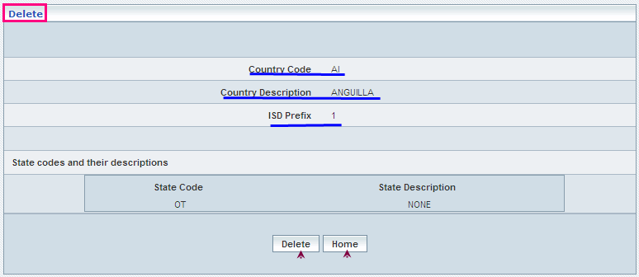

| **STEP** | **ACTION** |
| --- | --- |
|  | Click **Delete** in the **Action** column of the ‘Manage Country/State Codes’ page. Now Delete page opens displaying the corresponding details of the Country Code. |
|  | Click the **Delete** button**.** A popup window opens for the confirmation.  Wor98 |
|  | On clicking the  button of the alert message window, the chosen Country code will be successfully deleted and a message window will be displayed to that effect.  Wor99  On clicking the  button of the message window, it redirects the user back to the (Manage Country/State Codes) records grid.  On clicking the  button of the alert message window, it retains the ‘Delete’ screen without deleting any Country code. |
|  | On clicking the  button of the ‘Delete’ screen (without confirming any deletion), it redirects the user back to the (Manage Country / State Codes) records grid. |

**Searching for a specific Country**

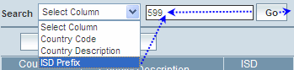

| **STEP** | **ACTION** |
| --- | --- |
|  | Select a search criterion (Country Code, Country Description, ISD Prefix) from the drop-down list of the search criteria of the <Search> field |
|  | Enter the value that corresponds with the given search criterion. |
|  | On clicking the  button, the corresponding Country/State code will be highlighted among the list of Country Code records. |

The screen below depicts fetching and displaying the Country Code (record).

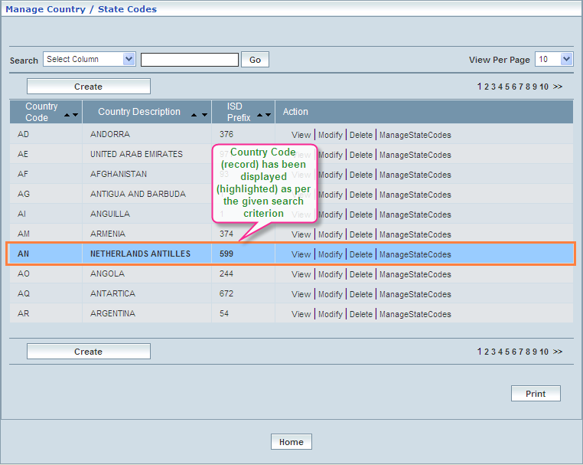

**Manage State Codes**

**‘Manage State Codes’** option allows the Super User (**SU**) creating (add) State codes to the chosen Country code.

This screen further allows the user to perform the following actions:

* View State Codes and Descriptions of a chosen Country code
* Modify State Codes and Descriptions of a chosen Country code
* Delete State Codes of a chosen Country code

This sub-module also helps to fetch the records (State codes related to any given Network User Account) with the help of **‘Search’** option based on the provided search criterion. The search criteria include: State Code, State Description, and Country Code.

Initially, the list of existing State Codes will be displayed in a grid.

The screen below shows the creation & management of State codes related to the Country Codes.

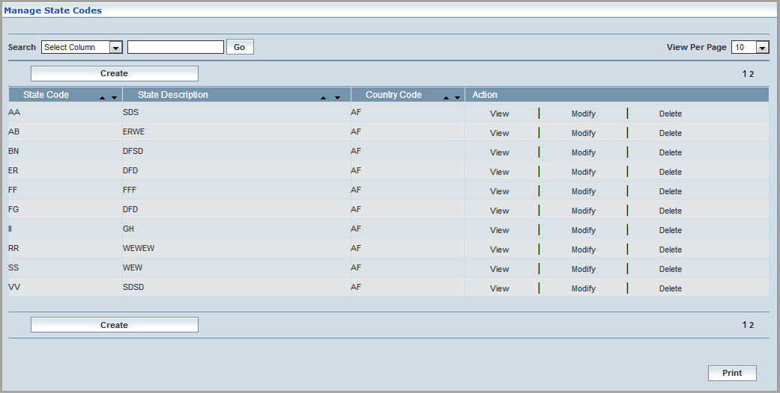

| **STEP** | | **ACTION** |
| --- | --- | --- |
|  | | By default, list of records for the existing State Codes are displayed in a grid. The columns include ‘State Code’, ‘State Description’, ‘Country Code’ and ‘Action’. |
|  |  | User can customize the view for the number of records to be displayed each time (per page) in a grid. |
| Select the number of records (For Ex: 10) from the drop-down list of the <View Per Page> field. |
| With the effect of choosing the desired number (10) for the display of records per page, the same (10 records) will be displayed in the grid. |
| However, based on the total number of records, page numbers will be dynamically displayed at the right bottom of the screen. |
| User can navigate for subsequent records (10 each time) by clicking the desired ‘page number’ |
|  | | User can sort the records in ascending and descending orders with the help of up-arrowNW Details and down-arrows NW Details respectively. |
|  | | On clicking the  button, ‘Create State Code’ screen will be displayed, which enables the user to create a State code. |
|  | | On clicking the  link, the corresponding State code details will be displayed in a separate screen. |
|  | | On clicking the  link, corresponding details will be displayed in a separate screen where user can edit the values. |
|  | | On clicking the  link of a chosen State code, the corresponding details will be displayed in a separate screen, which enables the **SU** to delete desired number of state codes. |
|  | | User can print the list of records with the help of NW Details button at the Right bottom of the screen. |
|  | | On clicking the  button of the ‘Manage State Codes’ grid, it redirects the user back to Home Page. |

**Create:**

To create a State code, click the  button. Create State Codes screen will be displayed enabling the user to create a State code.

The screen below shows creating a new ‘State code’ to the chosen country Code.

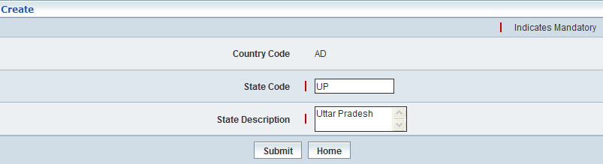

| **STEP** | **ACTION** |
| --- | --- |
|  | User must enter the ‘State Code, and State Description’. However, by default, the Country Code to which you wish to add a State Code is displayed. |
|  | On clicking the  button, the new State code will be part of the existing State code(s) of the Country Code and a message window will be displayed to that effect.    On clicking the  button of the message window, it redirects the user back to the (Manage State Codes) records grid. |
|  | On clicking the  button, it redirects the user back to the (Manage State Codes) records grid. |

**View:**

The screen below shows the ‘View’ of the State codes.

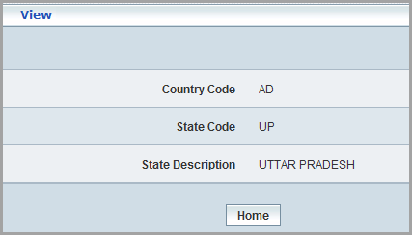

| **STEP** | **ACTION** |
| --- | --- |
|  | Click  in the Action Column of the screen against any State code. |
|  | On clicking the  link of a chosen State code, corresponding details will be displayed in a separate screen. |
|  | User can peruse the details accordingly. |
|  | On clicking the  button, it redirects the user back to the (Manage State Codes) records grid. |

**Modify:**

The screen below shows the ‘Modify of the State Code details.

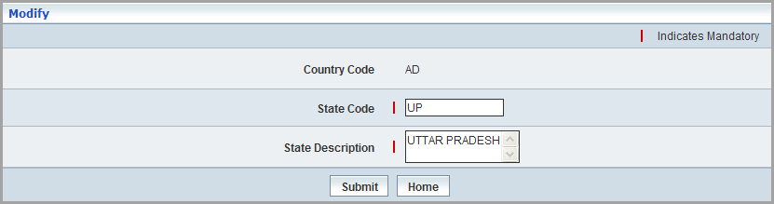

| **STEP** | **ACTION** |
| --- | --- |
|  | Click **Modify** in the **Action** Column of the screen against any State code. |
|  | On clicking the **Modify** link of a chosen State code, corresponding details will be displayed in a separate screen where user can edit the values. |
|  | User can edit the details accordingly. |
|  | On clicking the  button, a message window will be displayed to that effect showing the existing and updated values. |
|  | On clicking the  button, it redirects the user back to the (Manage State Codes) records grid. |

**Delete:**

The screen below shows deleting the desired State codes.

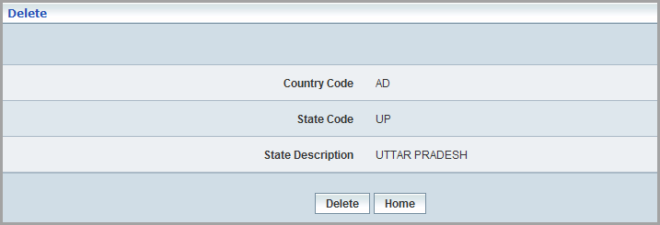

| **STEP** | **ACTION** |
| --- | --- |
|  | Click **Delete** in the **Action** column of the ‘Manage State Codes’ page. Now Delete page opens displaying the information of the State Code. |
|  | Click the **Delete** button**.** A popup window opens for the confirmation. |
|  | On clicking the  button of the alert message window, the chosen State code will be successfully deleted and a message window will be displayed to that effect.    On clicking the  button of the alert message window, it retains the ‘State Codes Delete’ screen without deleting any State code.  On clicking the  button of the message window, it redirects the user back to the (Manage State Codes) records grid. |
|  | On clicking the  button of the ‘State Codes Delete’ screen, it redirects the user back to the (Manage State Codes) records grid. |

**Searching for a specific State Code**

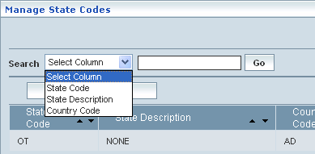

| **STEP** | **ACTION** |
| --- | --- |
|  | Select a search criterion (State Code, State Description, Country Code) from the drop-down list of the search criteria of the <Search> field. |
|  | Enter the value that corresponds with the given search criterion. |
|  | On clicking the  button, the corresponding State code will be highlighted among the list of State Code records. |

## Network Operator Login

Login page helps different users of the independent Network (Administrator, Functional Operators and Customer Personnel) logging into **MSP**.

Administrator is at the top level on the users’ hierarchy. Administrator logs into **MSP** with a valid Login and Password (provided by the Super User). Admin can create user accounts for different Functional Operators and Customer Care personnel, which are normally under his/her control for assigning various roles and user permissions. Login page allows the authorized users to login to the **MSP** application with the help of their respective Login names and passwords.

The screen below shows the Login page for various Users.

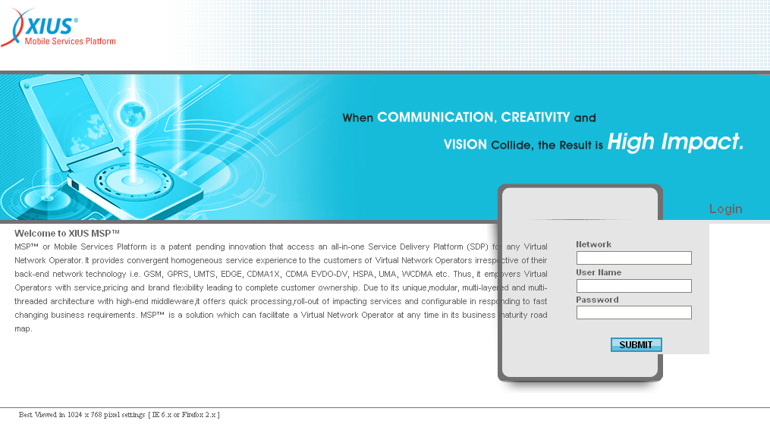

| **STEP** | **ACTION** |
| --- | --- |
|  | User to enter network name, his / her valid user name and password in their respective <Network>, <User Name> and <Password> fields |
|  | On clicking the Super Log In button, ‘Application Home Page’ will be displayed, enabling the User to access various application modules |

The screen below shows the Application Home Page.

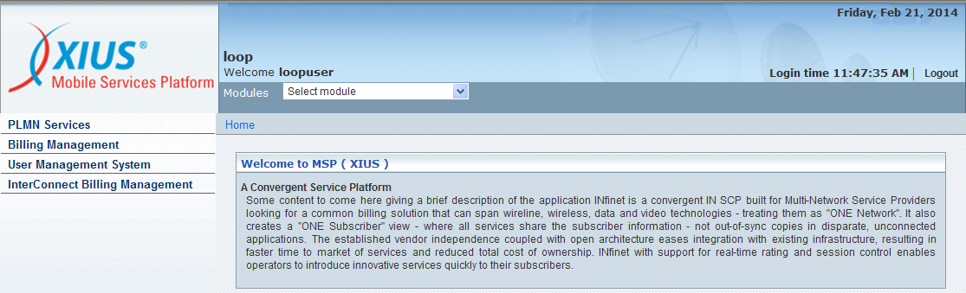

## Application Logout

Users can logout of the application any time and from anywhere steering through application, with the help of the **logout button** link (at the right top corner of the screens).

The screen below shows the **logout button** link.

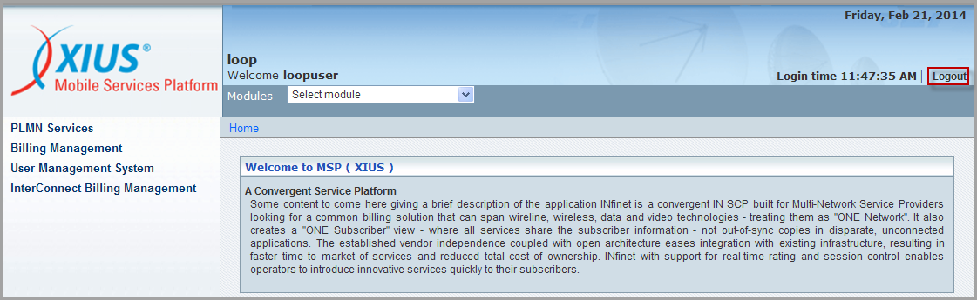

| **STEP** | **ACTION** |
| --- | --- |
|  | On clicking the **logout button** link, a screen will be displayed initiating the user to confirm logout. |

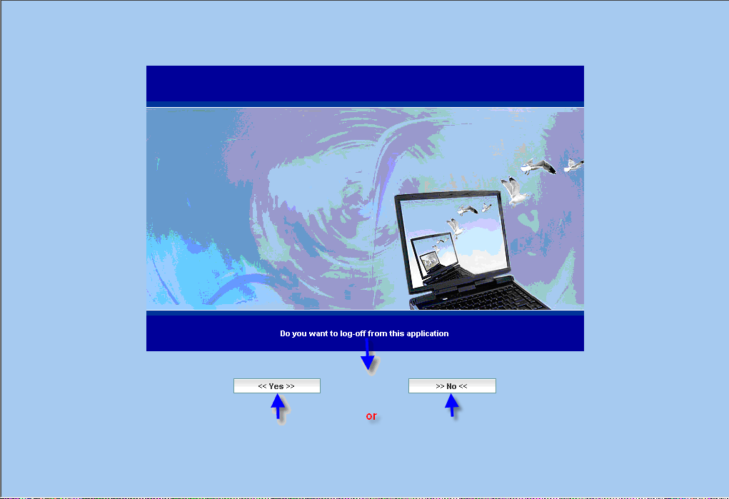

| **STEP** | **ACTION** |
| --- | --- |
|  | On clicking the **logout** button, user successfully logs out of the application and the message (‘you have been logged out successfully’) to that effect will be displayed. |

The screen below shows the ‘Logout’ message.

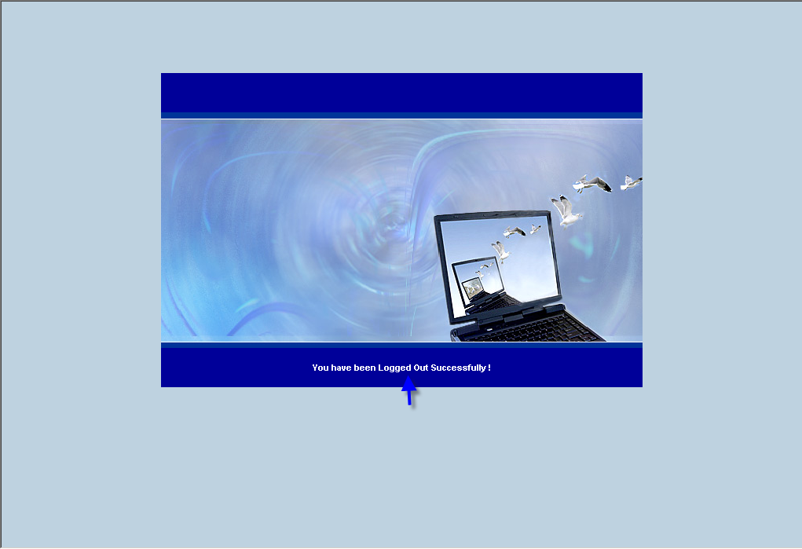

| **STEP** | **ACTION** |
| --- | --- |
|  | On clicking the **logout** button, user will be directed to the home page of the **MSP** Application. |

**\* Logout process to the Super User is similar to that of the Network Administration Logout.**